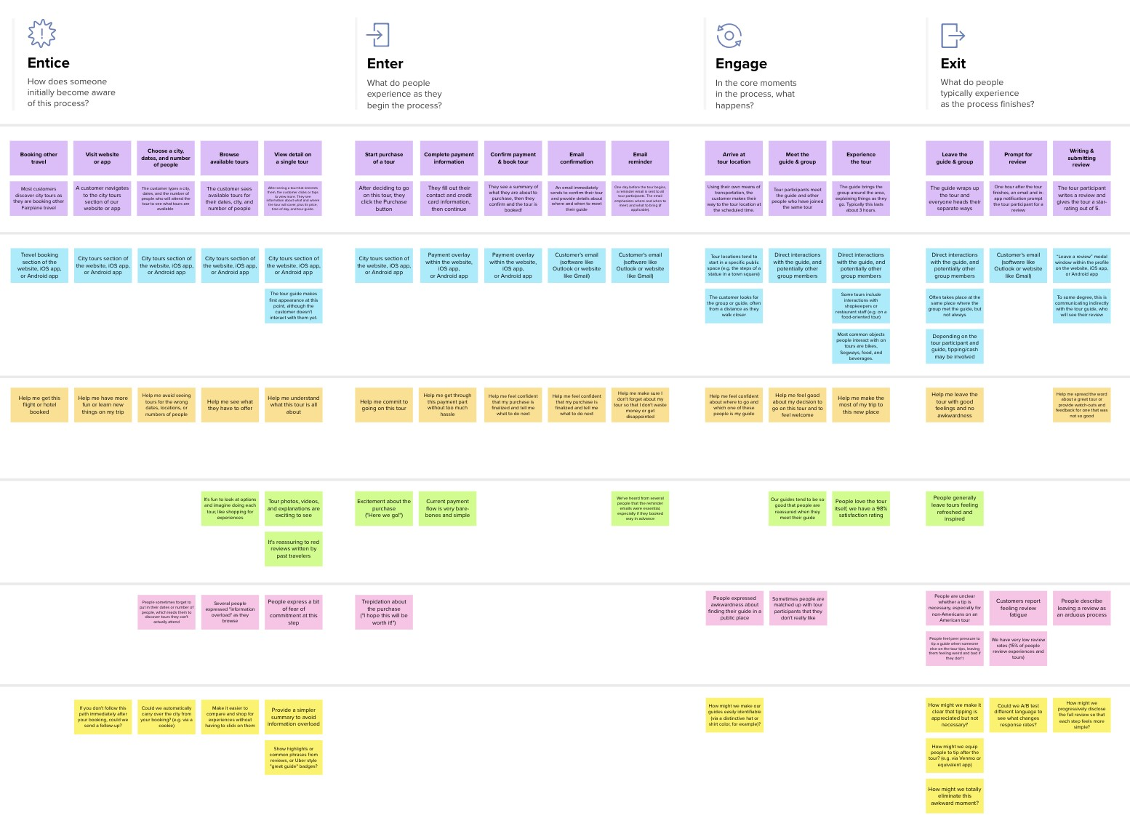

**Template**

✴

**Document an existing experience**

**TIP**

As you add steps to the experience, move each these “Five Es” the left or right depending on the scenario you are documenting.

Narrow your focus to a specific scenario or process within an existing product or service. In the **Steps** row, document the step-by-step process someone typically experiences, then add detail to each of the other rows.

**Customer experience journey map**

**Browsing, booking, attending, and rating a local city tour**

|  |  |  |  |  |  |
| --- | --- | --- | --- | --- | --- |
| **SCENARIO**  Swimming Pool, Safe- Guard, Drowning, Alerting. | **Entice**  How does someone initially become aware of this process? | | **Enter**  What do people experience as they begin the process? | **Engage**  In the core moments in the process, what happens? | **Exit**  What do people typically experience  as the process finishes? |
| **Steps**  What does the person (or group) typically experience? | **Knowledge**  They will know about the good part of this tool | **Learning**  Learn about How the thing detects. | **Secure** | we are very glad,that we become a unforgettable part in their life. | It gurantees once life. |
|  | people will feel comfort & secure |  |  |
| **Interactions**  What interactions do they have at each step along the way? | It always active to detect the person in the pool | This is deisgn to place in the Theme parks,Swimming pools and Hotels. | Idea |  | they feel very sad |
| **People:** Who do they see or talk to?  **Places:** Where are they? |  | It can interact with the Life guard in the emergency situation | By viewing more clear picture they got new ideas | It will give lots of assist to the safeGuard |  |
| **Things:** What digital touchpoints or physical objects would they use? |  |  |  |  |  |
| **Goals & motivations** | This is to provide the extra safety to the peoples in pools | Goal of the project is to ensure that the high priority. |  |  |  |
| At each step, what is a person’s primary goal or motivation? (“Help me...” or “Help me avoid...”) | Proved | Spreading information to all kind of people | We overcome the drawbacks and create new models |
|  | They feel very proud for having such kind of things |  |  |
| **Positive moments**  What steps does a typical person find enjoyable, productive, fun, motivating, delightful, or exciting? | It will save an once life in the pool | | Technology We can trust this technology blindly. | The model learn lot of new movements to detect drowning | We learn lot of new things |
| **Negative moments**  What steps does a typical person find frustrating, confusing, angering, costly, or time-consuming? | The system might fail to handle the situation that leads nasty. | | People who unfamiliar with the technology cant trust easily. | Budget is high so not everyone can afford this at home | It takes more time to bulid the accurate model |
| **Areas of opportunity**  How might we make each step better? What ideas do we have? What have others suggested? | By using AI tools to Detect the dangerous situation | Using ANN & CNN to detect a precise action. | All peoples to easy to understand | It helps to everyone | We provide better quality models & software |

Use this framework to better understand customer needs, motivations, and obstacles by illustrating a key scenario or process from start to finish.



When possible, use this map to document and summarize interviews and observations with real people rather than relying on your hunches or assumptions.



Created in partnership with



[**Share template feedback**](https://muralco.typeform.com/to/CiqaHVat?typeform-source=app.mural.co)



**Need some inspiration?**

|  |  |  |  |  |  |  |  |  |
| --- | --- | --- | --- | --- | --- | --- | --- | --- |
|  |  |  |  |  |  |  |  |  |
|  |  |  |  | |  |  |  |  |

|  |  |  |  |  |  |  |  |  |
| --- | --- | --- | --- | --- | --- | --- | --- | --- |
|  |  |  |  |  |  |  |  |  |
|  |  |  |  | |  |  |  |  |

See a finished version of this template to kickstart your work.

[**Open example**](https://app.mural.co/template/f59f644b-b4b4-47b5-9ed6-3a8c71ceb612/896b31fe-5597-40ef-9b06-3811a1a45ace)